POSAM to do

Movement IN / OUT check for extraction

On Item, when she wants to see the IN inventory, she had to check all entries.

She will need the possibility to select only IN or OUT or both using also the date criteria.

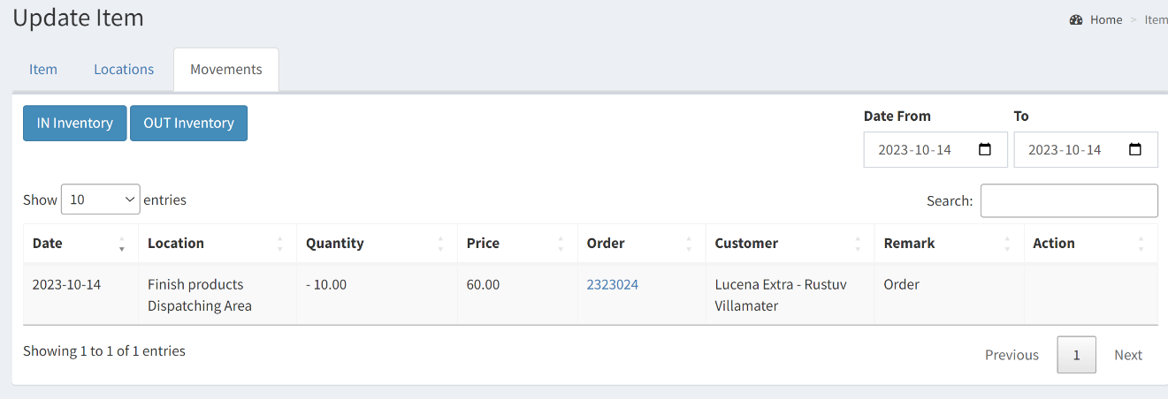

DATE

Seems to have a problem with the date on the server. When they have order on Friday, it will not enter in the calculation of the inventory.

PRICE

Changing the price of a raw materiel is not reflect in the transaction. Why do I keep the rate in the movement and this is not reflected with raw materiel.

Cooking oild RM007

Le problème est que quand elle met à jour l’inventaire des raw materiel elle ne passe pas par les orders. Il faut donc garder le prix ancien quand elle change de prix pour qu’elle puisse voir l’évolution.

ITEM and decimal

The process of decimal for the quantity doesn’t work in the IN OUT inventory. It was completed with ordering but not for IN OUT like same as the price….

DASHBOARD

Statistics?

Sales per month (order or money)

Sales per year

Production LEVEL

Should be Ordering Point:

Add a field Safety Stock:

C’est la quantité necessaire pour assurer la suite des opérations

Item no 1 – 500 in stock

Safety stock : 100 in stock 20% in percentage

Ordering Point : 50 it’s urgent to order 10%

Item by safety stock could be a report but better in the Dashboard.

BACKUP

Find a plugin for backup of the webiste

**Customer screen**

Try to improve this screen. May be more speed or add some indexes, or less info. It’s a little bit slow to come and sometimes they have database problem.